# Classes and objects

Class: - class is a blue print/ template to create an object.

Object: - an object is a real time entity that describes the state and behaver.

* Non-static variable defines the state.
* Non-static method defines the behaver.
* State defines what date should be passed.
* Behaver defines the way it can behave.
* Whenever an object is created we will have state and behaver.
* All the object address will be stored in the reference variable.
* We can store the object address in multiple reference variable.
* We can store multiple objects in multiple reference variable.

Example

* In real life, a car is an object. The car has attributes, such as weight and color, and methods, such as drive and brake.
* A dog has states - color, name, breed as well as behaviors – wagging the tail, barking, eating.

Class Diagram

it is a pictorial representation to represent the members of the class.

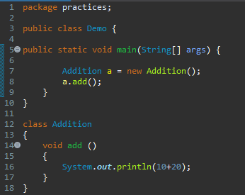

Has a

relationship

class

Demo

Addition: a

Addition

Void add

# Composition

A class having an object of another class is called as composition, it is also called as “**has-a-relationship”**.

Advantages of composition:

* Reuse of code.
* By using composition we can achieve multiple inheritances.
* Better test ability of a class.
* It is achieved by instance variable that refers to other objects.

Example:

